

**COMSATS University Islamabad (Lahore Campus)**

**<Assignment 1> – SPRING 2024**

|  |  |  |  |  |  |
| --- | --- | --- | --- | --- | --- |
| Course Title: | Game Development | Course Code: | CSC495 | Credit Hours: | 3 |
| Course Instructor/s: | Saira Aslam | Program | BSE | | |
| **Submission Deadline** | **11:55 pm, 22-3-2024** | **Maximum Marks:** | **50** | | |
| **Important Instructions / Guidelines:**   * Submit a 10 seconds video, 4 screenshots, and all your scripts in Lab Assignment 1 submission at google classroom * Paste your screenshots and scripts inside Lab Assignment-1 submission file provided | | | | | |

***Question No 1.***

***CLO: <3>; Bloom Taxonomy Level: <****Apply****>* [80]**

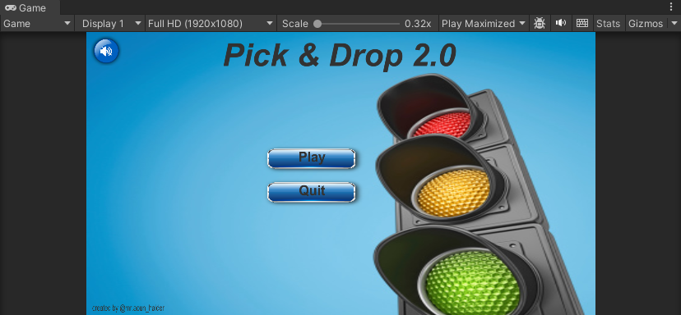

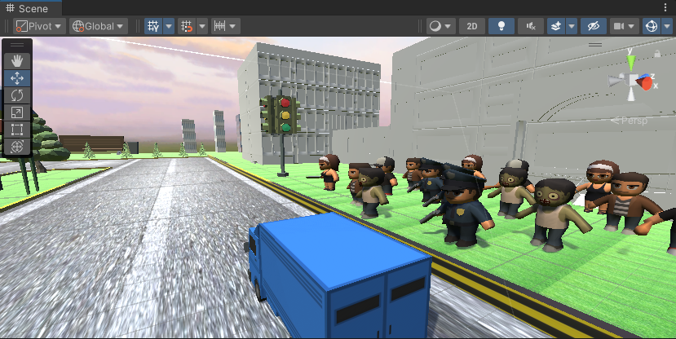

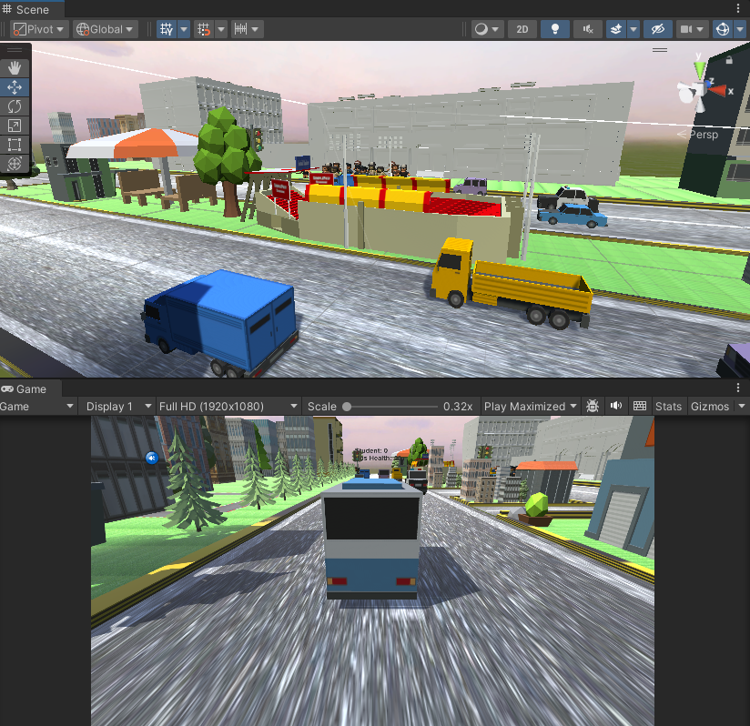

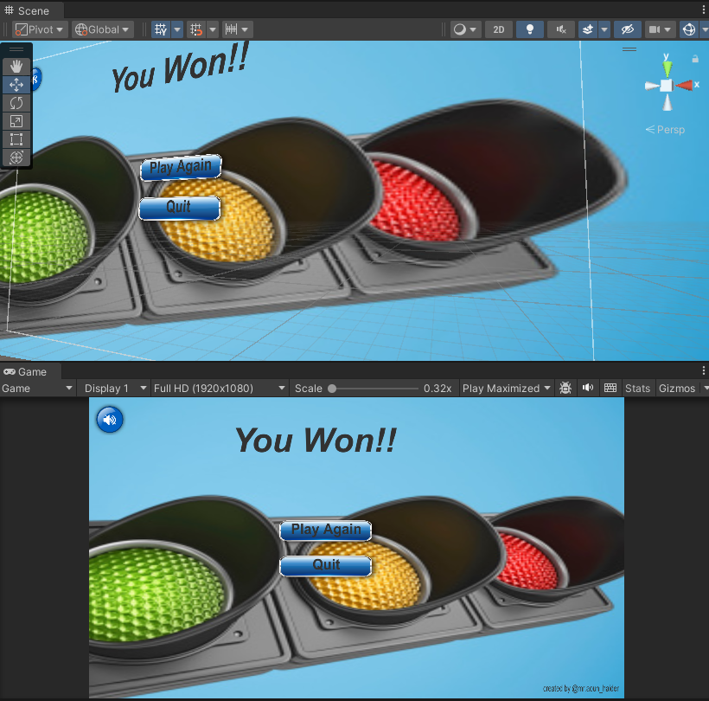

**busScript.cs**

using System.Collections;

using System.Collections.Generic;

using UnityEngine;

using UnityEngine.UI;

using UnityEngine.SceneManagement;

public class BusScript : MonoBehaviour

{

    public Text busHealth;

    public float health = 50;

    public float speedStrength;

    public bool insideObject = false;

    private int numOfStudents = 0;

    public GameObject[] students;

    public int leftStudentCount = 3,rightStudentCount = 0;

    public AudioSource hornSound;

    // Start is called before the first frame update

    void Start()

    {

        students = new GameObject[6];

        //Extract all the game object and store in array

        for(int i=1;i<7;i++)

        students[i-1] = GameObject.Find("School_Childrens_"+i.ToString());

        busHealth.text = "Student: " + numOfStudents.ToString() + "\nBus Health: " + health.ToString();

        hornSound = GetComponent<AudioSource>();

    }

    // Update is called once per frame

    void Update()

    {

        // Move the bus based on user input

        if (Input.GetKey(KeyCode.UpArrow)) //move forward

        {

            transform.Translate(0, 0, speedStrength);

        }

        if (Input.GetKey(KeyCode.DownArrow)) //move backward

        {

            transform.Translate(0, 0, -speedStrength);

        }

        if (Input.GetKey(KeyCode.LeftArrow)) //move left

        {

            transform.Rotate(0, -speedStrength, 0);

        }

        if (Input.GetKey(KeyCode.RightArrow)) //move right

        {

            transform.Rotate(0, speedStrength, 0);

        }

        if (Input.GetKeyDown(KeyCode.H))

        {

            hornSound.Play();

        }

        // Check if the bus health is zero

        if (health <= 0)

        {

            SceneManager.LoadScene("GameOver_Scene");

        }

        if(numOfStudents == 30)

        {

            SceneManager.LoadScene("GameWin");

        }

        if(insideObject && Input.GetKey(KeyCode.Space))

        {

             if(transform.position.z > -60 && rightStudentCount < 3) //right side

             {

                Destroy(students[rightStudentCount]);

                numOfStudents += 5;

                rightStudentCount++;

                busHealth.text = "Student: " + numOfStudents.ToString() + "\nBus Health: " + health.ToString();

             }

            else if(transform.position.z < -60 && (leftStudentCount > 2 && leftStudentCount < 6)) //left side

            {

                Destroy(students[leftStudentCount]);

                numOfStudents += 5;

                leftStudentCount++;

                busHealth.text = "Student: " + numOfStudents.ToString() + "\nBus Health: " + health.ToString();

            }

            insideObject = false;

        }

    }

    private void OnCollisionEnter(Collision col)

    {

        if (col.gameObject.name.StartsWith("Car") || col.gameObject.name.StartsWith("Truck"))

        {

            health -= 10;

            busHealth.text = "Student: " + numOfStudents.ToString() + "\nBus Health: " + health.ToString();

        }

        if(col.gameObject.name.StartsWith("Pickup_boundary"))

        {

                insideObject = true;

        }

    }

    private void OnCollisionExit(Collision col)

    {

        if(col.gameObject.name.StartsWith("Pickup_boundary"))

        {

            insideObject = false;

        }

    }

}

**buttonScript.cs**

using System.Collections;

using System.Collections.Generic;

using UnityEngine;

using UnityEngine.UI;

using UnityEngine.SceneManagement;

public class buttonScript : MonoBehaviour

{

    public Button btn;

    public void Start()

    {

        btn.onClick.AddListener(clickHandler);

    }

    public void clickHandler()

    {

        SceneManager.LoadScene("Main_Scene");

    }

}

**collisionScript.cs**

using System.Collections;

using System.Collections.Generic;

using UnityEngine;

public class CollisionScript : MonoBehaviour

{

    public GameObject student;

    // Start is called before the first frame update

    void Start()

    {

    }

    // Update is called once per frame

    void Update()

    {

    }

    // private void OnCollisionEnter(Collision col)

    // {

    //     if(col.gameObject.name.StartsWith("Bus"))

    //     {

    //         Debug.Log("Entered!");

    //         if(Input.GetKey(KeyCode.Space))

    //         {

    //         Debug.Log("Space Pressed!");

    //             Destroy(student);

    //         }

    //     }

    // }

}

**mainMenuButtonScript.cs**

using System.Collections;

using System.Collections.Generic;

using UnityEngine;

using UnityEngine.SceneManagement;

public class mainMenuButtonScript : MonoBehaviour

{

    public AudioSource audioSound;

    void Start()

    {

        audioSound = GetComponent<AudioSource>();

        audioSound.Play();

    }

    public void LoadLevel_1()

    {

        SceneManager.LoadScene("Main_Scene");

        audioSound.mute = true;

    }

    public void QuitGame()

    {

        Application.Quit();

    }

}

**soundControllerScript.cs**

using System.Collections;

using System.Collections.Generic;

using UnityEngine;

public class soundControllerScript : MonoBehaviour

{

    public GameObject mute,unmute;

    private bool muteFlag = false;

    void Start()

    {

        if(muteFlag)

        {

            mute.SetActive(false);

            unmute.SetActive(true);

            AudioListener.volume = 0;

        }

        else

        {

            mute.SetActive(true);

            unmute.SetActive(false);

            AudioListener.volume = 1;

        }

    }

    // Update is called once per frame

    public void muteGame()

    {

        mute.SetActive(false);

        unmute.SetActive(true);

        AudioListener.volume = 0;

        muteFlag = false;

    }

    public void unmuteGame()

    {

        muteFlag = true;

        mute.SetActive(true);

        unmute.SetActive(false);

        AudioListener.volume = 1;

    }

}

**trafficScript.cs**

using System.Collections;

using System.Collections.Generic;

using UnityEngine;

public class trafficScript : MonoBehaviour

{

    // Start is called before the first frame update

    void Start()

    {

    }

    // Update is called once per frame

    void Update()

    {

        transform.Translate(-0.3f,0,0);

        Vector3 trafficPosition = transform.position;

        if(trafficPosition.x < -2170)

        {

            trafficPosition.x = -1325;

            transform.position = trafficPosition;

        }

    }

}